Name: RAKAM ABHINAY
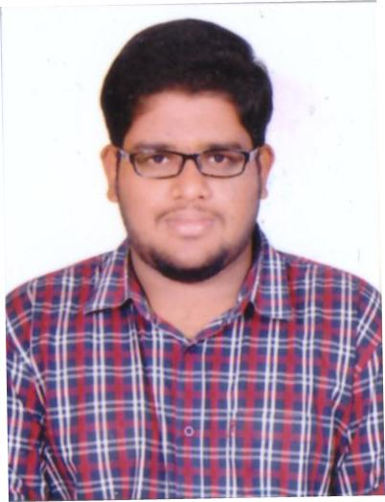

Designation: ASSISTANT PROFESSOR

Department: Civil Engineering

Mail ID: rakamabhinay@scce.ac.in; rakamabhinay@gmail.com

Contact Number: +91-9849552827

Experience (in years): 1 |  |  | Teaching: 1 Research: |  |  | Industry:
1. Educational / Technical qualifications:
 | S.No. | Level (UG / PG / Ph.D) |  | Year of passing |  | Specialization
 | 01 | PhD  (Lovely professional university) |  | Pursing | CONCRETE
 | 02 | M.TECH  ( Malla reddy institute of technology) |  | 2017 | STRUCTURAL ENGINEERING
 | 03 | B.TECH  (Sree chaithanya college of engineering) |  | 2015 | CIVIL ENGINEERING

- Teaching Interests:

Undergraduate level:
Concrete Technology
Reinforced Cement Concrete Structures Design And Drawing
Hydraulic machineries and Fluid mechanics
Building materials and construction planning
Soil mechanics
Steel Structures Design And Drawing
Strength of Materials

Postgraduate level:
Advanced Reinforced Concrete Structures,
Advanced Concrete Technology
Structural Dynamics
Prestressed Concrete

- Co-curricular and Extra-Curricular Activities: Sports, Journal reading , writing

4. Conference / Workshop / Seminar / Guest Lectures attended

S.No. | Workshop/Conference | Organized by | Duration & Year
1 | Structural Engineering Solutions | Department of Civil Engineering; malla reddy institute of technology | Two days, aug-2017
2 | Special concretes | Department of civil engineering in JNTUH university | One day,oct-2018
3 | Intellectual property rights | Sree chaitanya college of Engineering | 16-11-2018 & 17-11-  2018

5. Academic Contribution and Research & Consultancy
- Invited Lectures:
- Articles / Chapters published in Books:

- Books published as single author or as editor:
- Projects Guided:
- Research Interests:
Self Compacting Concrete; Recycled Aggregate Concrete; Prestressed Concrete;Repair and Rehabilitation of Concrete structures,FRP Technology for Strengthening and Rehabilitation of Structures

5.6. Papers published in International / National journals: 1

S.No. | Title of the Paper | Journal Name Vol. No. pp. | ISBN/ISSN No. | Impact factor/ Citation Index | National/ International
1. | LIGHT WEIGHT CONCRETE PREPARATION BY USING OF WASTE PLASTIC | International Journal of innovative technology and research(IJITR),Vol.No.5, July-2017 | 4 |  | International

5.7. Papers presented at National / International Conferences:
S.No. | Title of the Paper | Names of the Conference/ Seminar | National/ International | Period
1.

- Employment History : :
    - Present Working as assistant professor in Sree Chaitanya college of engineering from 24-01-2018 to till date
    - Worked as part time assistant professor in the department of agriculture engineering at
Nigama engineering college Karimnagar

- Academic/ Administrative/Social responsibilities:
  - Class Coordinator for 4th year B.Tech. Civil Engineering in SCCE, Karimnagar
  - Lab In charge of environmental engineering and concrete lab at Department of Civil Engineering, SCCE, Karimnagar.
  - NACC in charge in civil department scce

- Awards / Honors received
Received cash prize in B.Tech. For being top in concrete technology subject
Received BEST STUDENT AWARD in Class X.

