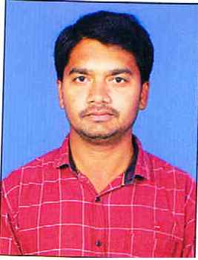

BURRA SANTHOSH KUMAR
Assistant Professor
Department of Pharmaceutical Analysis

- Academics
- CURRENT ACADEMIC ROLE & RESPONSIBILITIES
Burra santhosh kumar assist Professor in the Department of Pharmceutical analysis, SCIPS.
He is involved in
- Handling classes for various pharmaceutics related subjects for M.Pharmacy, B.Pharmacy courses
- Recognised Guide for Projects of UG, PG courses

- SUBJECTS CURRENTLY TEACHING
Subject | Year / Semester
Pharmaceutical Analysis –II (Theory & practical) | B.Pharmacy IV-II sem
Chemistry of natural products (theory) | B.Pharmacy III Year II Sem

- ACADEMIC QUALIFICATIONS
Degree | Specialisation | Institute/ University | Year of passing
M Pharmacy | Pharmaceutical Analysis | Trinity college of pharmaceutical sciences peddapalli | 2014
B.Pharmacy |  | Jyothishmathi institute of pharmaceutical sciensess karimnagar | 2011

EXPERIENCE
Institution / Organisation | Designation | Role/ Department | Tenure
Sree Chaitanya Institute of Pharmaceutical Sciences | Assist Professor | Pharmaceutical analysis II | March 2016 to till date
expertise
- AREAS OF INTEREST, EXPERTISE AND RESEARCH
Areas of Interest | Method development and validations by UV and HPLC, Gas chromatography , Lc-Ms , Biochemistry, ,Flame photometry, Flourimetry
Areas of Expertise | In method dev elopement and validations

STUDENT PROJECTS (Both PG & UG )
Devolopement & Valodation of Stability Indicating RP HPLC method for Analysis of Benazepril HCL and Amlodipine Bisilate in its bulk and pharmaceutical dosage form P Srividya 2017-18
Simultaneous estimation of Gliclazide metformion and Pioglitazone by UV spectroscopical method using multicomponent method 2017-18 MD Salman pasha, Divya sri, Sai teja, Y Lavanya 2017-18

