Name: BASETTY SAI KUMAR
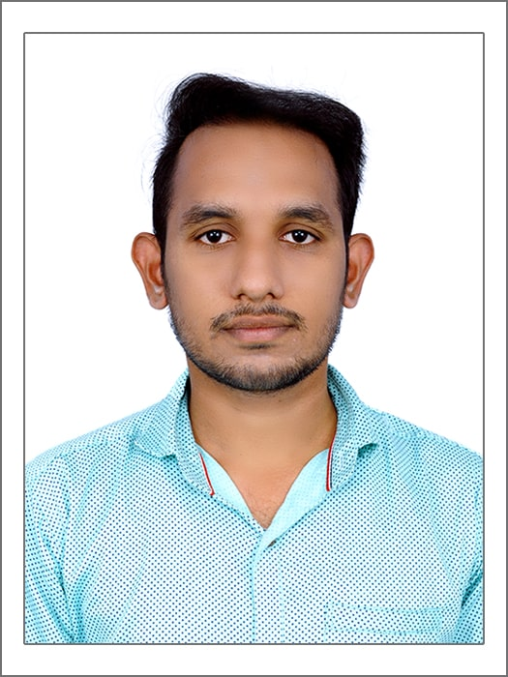

Designation: ASSISTANT PROFESSOR

Department: Civil Engineering

Mail ID: b.saikumar3924@gmail.com

Contact Number:8341762921

Experience (in years): 1 Teaching: 11 months Industry: 06 months
1. Educational Technical qualifications:
 | S.No. | Level (UG / PG / PhD) |  | University/institute |  | Year of passing |  | Specialization
 | 1 | M.Tech |  | JNTU A |  | 2017 | Structural engineering
 | 2 | B.Tech |  | JNTU K |  | 2015 | Civil engineering

- Teaching Interests: concrete technology, building construction and planning, structural analysis, strength of materials, water resource engineering

- Co-curricular and Extra-Curricular Activities
- Interested to learn many thing of inventions in civil engineering, reading novels, moral books & personality development books

- Conference / Workshop / Seminar / Guest Lectures attended

S.No. | Workshop/Conference | Organized by | Duration & Year
1 | Rehabilitation and retrofitting of concrete structures | VIT-VELLORE | 2 days-2017
2 | Compressed stabilized earthen blocks | AUROVILLE EARTH INSTITUTE-PONDICHERRY | 1day-2017
3 | Bio inspired materials by design | NITW | 3-DAYS-2018

5. Academic Contribution and Research & Consultancy
- Invited Lectures: NILL
- Articles / Chapters published in Books: NILL

- Books published as single author or as editor: NILL
- Projects Guided: NILL
- Research Interests: concrete structures

5.6. Papers published in International / National journals:

S.No. | Title of the Paper | Journal Name Vol. No. pp. | ISBN/ISSN No. | Impact factor/ Citation Index | National/ International
1. | Structural investigation on cost effective roofing technology | IJSRD | 23210613 |  | INTERNATIONAL

5.7. Papers presented at National / International Conferences:

S.No. | Title of the Paper | Names of the Conference/ Seminar | National/ International | Period
1. | papercrete | SRKR | National | 2 days

- Employment History
  - Assistant Professor in Sree Chaitanya College of Engineering, Karimnagar, Telangana from 29th jan, 2018 to till date

- Academic/ Administrative/Social responsibilities
  - Seminar Coordinator for IV year B.Tech. Civil Engineering Projects in SCCE, Karimnagar

- Awards / Honors received
- Got gold metal shield in B.Tech level for being the topper of the college
- Achieved best student award in B.Tech batch
- Got winner in national level technical paper presentations
- Received memento for model expo on science day

