BIODATA
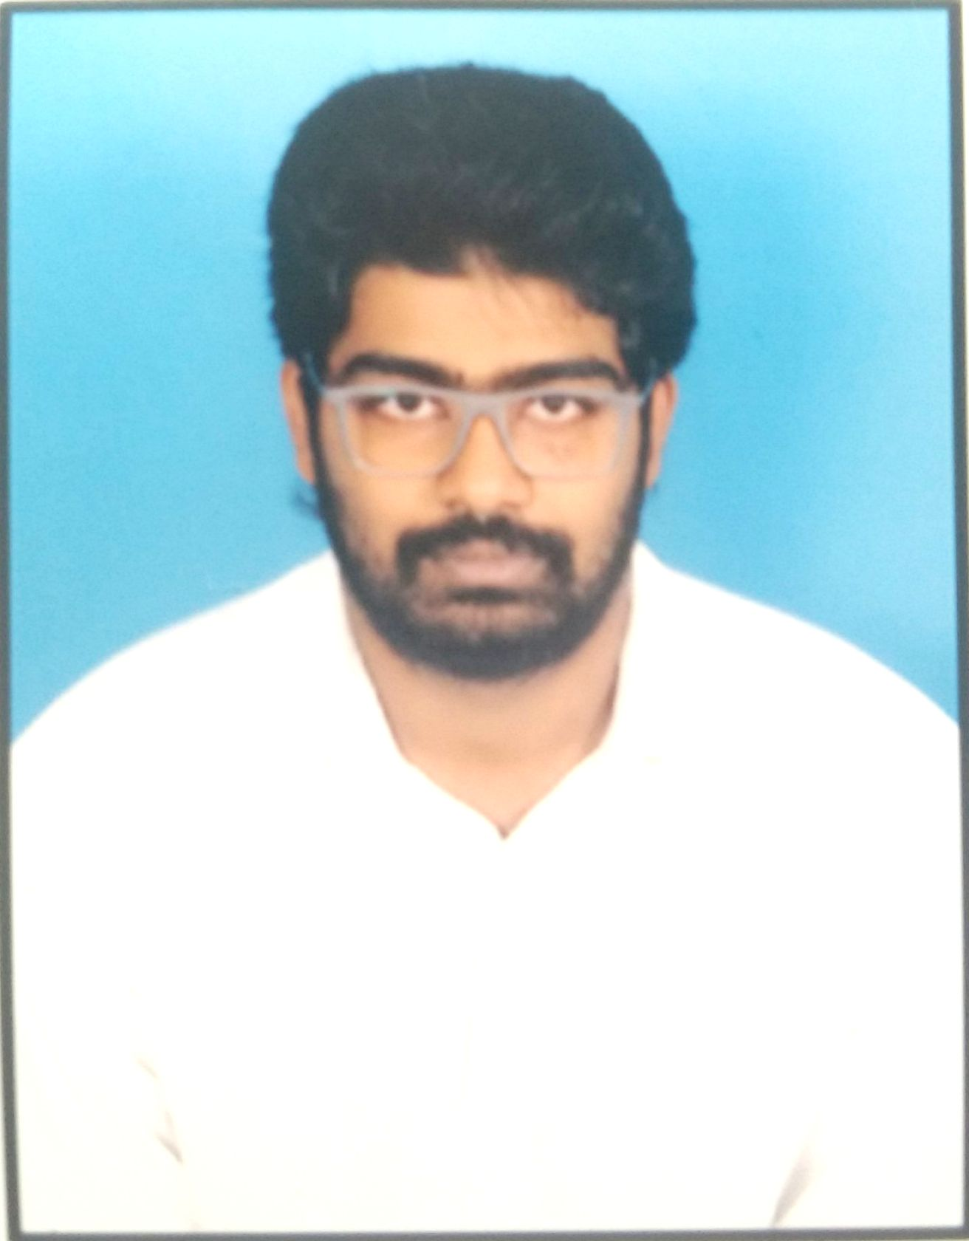
Add Photo
Name: SIVANANDA REDDY YENNAM.

Designation: ASST PROFESSOR.

Department: Civil Engineering

Mail ID: SIVAREDDYS143@GMAIL.COM

Contact Number: 9949945920

Experience (in years): 1Y 4M |  |  | Teaching: 3M Research: 0 |  |  | Industry: 1Y 1M
1. Educational / Technical qualifications:
 | S.No. | Level (UG / PG / Ph.D) |  | Year of passing |  | Specialization
 | 1 | UNDER GRADUATE |  | 2015 | CIVIL
 | 2 | POST GRADUATION |  | 2017 | C.E.M
 | 3

- Teaching Interests: Concrete Technology and Construction Management

- Co-curricular and Extra-Curricular Activities:
▪ Reading Books
▪ Sports
▪ Movies

4. Conference / Workshop / Seminar / Guest Lectures attended

S.No. | Workshop/Conference | Organized by | Duration & Year
1 | National Seminar on the evening of "Concrete day Celebrations” | Gitam University | 2014
2 | National Seminor on "Geothechnics for Irrigation Projects" (Under TEQIP-II) | JNTUH | 2014
3 | Intellectual Property Rights | Sree Chaitnaya College of engineering | 2018
4 | Workshop on outcome based education | Sree Chaitnaya College of engineering | 2018

5. Academic Contribution and Research & Consultancy
- Research Interests: To Increase Proporties of Coconutshell concrete.

- Employment History:
  - Worked for NEERU-CHETTU projects under governement of Andhra Pradesh, in IRRIGATION DEPT Kalayanadurg Sub Division , Anantapur (dist),Andhra pradesh.
  - Worked juniour engineer for kaleshwaram Reserviour project at MEGHA ENGINEERING AND INFRASTRUCTERS LIMITED in Siddipet,Karimnagar,Telemgana
  - Working as Asst professor in SREE CHAITNAYA COLLEGE OF ENGINEERING, karimnagar.

- Academic/ Administrative/Social responsibilities:
  - Volunteer for PRAMANA 2K13- Tech festive
  - Participated in HARITHON- Green Run held on FEB-17th, 2103 in Hyderbad.
  - Participated National Seminar on the evening of "Concrete day Celebrations" which was conducted by GITAM UNIVERSITY, 2014. ▪ Participated in
  - National Seminor on "Geothechnics for Irrigation Projects" (Under TEQIP-II) held at JNTU Collage of Engineering on AUG-28, 2014

- Motto: I seek challenging opportunities in the company where I can fully use my technical and managerial skills for the success of the organization along with making my own personal and professional growth.

