CURRICULUM VITAE

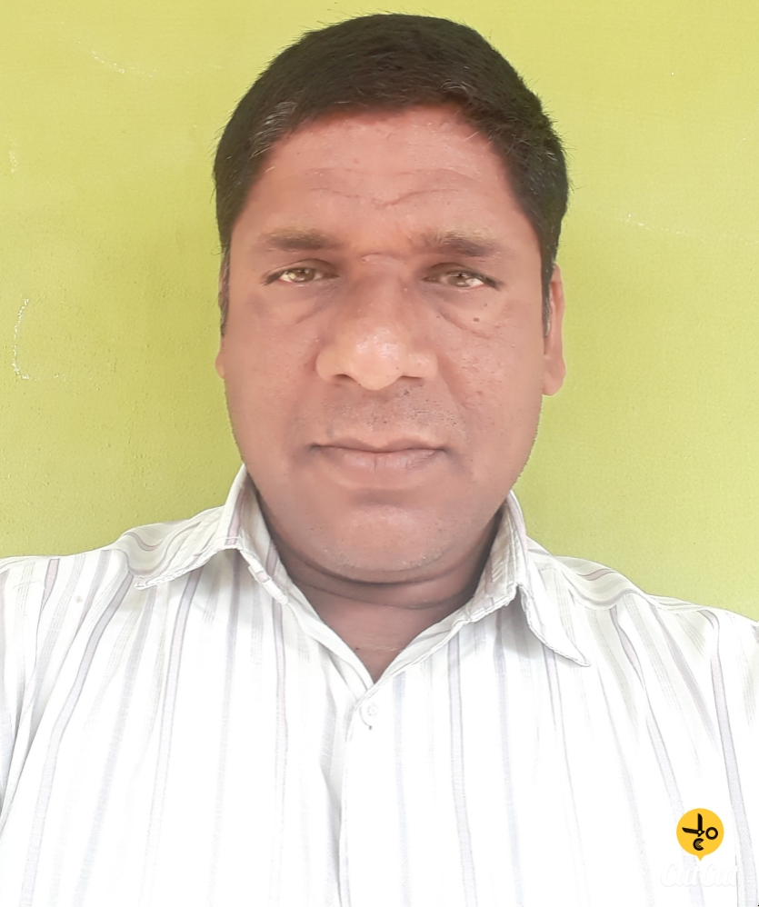

B. RAVINDAR, M. Tech,(Ph.D)
C/o Ch. Sathaiah,
H.No: 8-5-310,
Laxminager colony,
Karimnagar-505001,
TELANGANA STATE
Cell No: 9440690618
Email Id: bhanothuravindar@gmail.com

======================================================================

CAREER OBJECTIVE:
An opportunity to work in a vibrant and exciting environment that hones my skills and to contribute positively to works the growth and prosperity of the organization. And also to secure a position in this ever expanding field by virtue of my sincerity and dedication.
EDUCATIONAL PROFILE:
- (PhD) from Kakatia University. Warangal, TS, Submitted on 09.04.2019.
- M. Tech (Energy Management) from S. V. University, Thirupathi,
(2004-2006)
- B. Tech (Mechanical Engineering) from J. N. T. University, (1997-2001)
- Diploma in Mechanical Engineering from G.M.R.Polytechnic, Bhadrachalam (1996)
MEMBERSHIP:
Sl.No. | Organization | Membership Number
1 | Life Member of Indian Society for Technical Education (MISTE), New Delhi | LM61153
2 | Life Member of Institute of Engineers(MIE), India | M-145944-3
3 | Life Member of Indian Institute of Welding (IIW). | HYD/M/R-11339/L
PROJECT EXPERIENCE:
- Ph.D
Title: Experimental Studies on 5083 Aluminium Alloy Weldments Using Pulsed TIG and Friction Stir Welding Processes.
- M. Tech
Title: Auditing and conservation of Rayalaseema Thermal power project, Kadapa.
- B. Tech
Title: Computer Aided Design of IC Components.
- DME:
Title: Study, Design and Estimation of an Air Cooler.

JOB EXPERIENCE: 13 Years
- Working as an Associate Professor and HOD in Vaageswari College of Engineering, Karimnagar, from September, 2013 to till date.
- 2 years worked as an Associate Professor and HOD at Vivekananda Institute of Technology & Science, Karimnagar from August, 2011 to August, 2013.
- 3 years worked as an Associate Professor at Vaageswari College of Engineering, Karimnagar, during May 2008 to August 2011.
- 2 years worked as an Asst. Professor at Sree Visveswaraya Institute of Technology & Science, Mahaboobnagar, during 2006 to 2008.
- 1 year worked as a Service Engineer at M/s JOFLO CENTRIFUGES (P) LTD. Nacharam, Hyderabad, during the year of 2003 to 2004.
- 1 year worked as a Graduate Trainee Apprentice in NTPC Ramagundam, Karimnagar through BHEL during the year on June 2002 to June 2003.

INTERNATIONAL JOURNALS: 10
- B.Ravindar, M. Kiran Kumar, K. Rajashekar, G. Rajkumar “fabrication of stair climbing trolly using ANSYS Analysis”, International Journal of prevention and Control of Industrial Pollution (IJPCIP) 2018, 31-41 @ Journals Pub 2018. Vol. 4, Issue 1, All Right Reserved.
- B.Ravindar, M. Kiran Kumar, K. Rajashekar, G. Rajkumar “Design and fabrication of stair climbing”, Journal of engineering and innovative Research (JETIR), ISSN: 2349-5162, Vol. 5, Issue 9, September 2018.
- B. Ravindar, B.Naresh, Md. Asifuddin and Md. Abdul hadi “Design and fabrication of Agro vehicle for ploughing”, Journal of engineering and innovative Research (JETIR), ISSN: 2349-5162, Vol. 5, Issue 9, September 2018.
- B. Ravindar, Dr K. Eswaraiah, “Comparison of Pulsed TIG Welding and FSW Processes of 5083 Aluminium Alloy”, International Journal of Pure and Applied Mathematics, ISSN: 1314-3395, Vol. 118, May 2018.
- B. Ravindar, Dr. K. Gururaj, Dr.A.Somi Reddy “Comparative investigations of FS welding and Pulsed TIG welding processes of 5083 Aluminum Alloys” International Journal of Advanced Engineering Research and Science (IJAERS), ISSN: 2349-6495 Vol-3, Issue-1, Jan- 2016, pp.27-33.
- B. Ravindar, Dr. K. Gururaj, Dr.A.Somi Reddy “ Mechanical and Microstructure properties of Pulsed Tungsten Inert Gas and FS Welding of AA5083 Butt joint” IJISET - International Journal of Innovative Science, Engineering & Technology, ISSN 2348 – 7968, Vol. 3 Issue 1, January 2016. pp.280.286.
- B. Ravindar, Dr. K. Gururaj, Dr.A.Somi Reddy “ The influence of process parameters on microhardness and mechanical properties of FSW aluminium 5083 alloy butt joint” IJESRT -International Journal of Engineering Science & Research Technology, ISSN 2277 –9655, Vol. 4 Issue 11, Nov, 2015. pp.432.440.
- B. Ravindar and Dr.K. Gururaj “Effects of Friction Stir Welding Parameters on Butt Joint Properties of Aluminium Alloy 5083” International Journal of Innovative Research in Science, Engineering and Technology, ISSN: 2319-8753 ISSN (Print): 2347-6710 Vol. 4, Issue 7, July 2015, pp.6531-6537.
- B. Ravindar and Dr.K. Gururaj “Influence Of Process Parameters On Aluminium Alloy 5083 In Pulsed Gas Tungsten Arc Welding” International Journal of Mechanical And Production Engineering, ISSN: 2320-2092, Volume- 3, Issue-7, July-2015, pp.145-149.
- B. Ravindar, J. Laxman and Dr.K. Gururaj “Certain Investigations on the effect of Pulsed Tungsten inert gas welding parameters on Aluminium (5083) alloy” International Journal of Applied Engineering Research, ISSN 0973-4562 Vol. 10 No.44 (2015). pp. 31765-31770.

INTERNATIONAL CONFERENCES: 05
- B. Ravindar and k. Gururaj “Effects of Friction Stir Welding Parameters on Butt Joint Properties of Aluminium Alloy 5083” IFERP International conference Hyderabad, ISBN-9788192958035.
- B. Ravindar and k. Gururaj “Influence of Process Parameters on Aluminium Alloy In Pulsed Gas Tungsten Arc Welding” 24th International conference, 3rd 5083 may 2015, Chennai, India, ISBN-978-93-85465-07-9.
- B. Ravindar, J Laxman and Dr.K. Gururaj “Certain Investigations on the effect of Pulsed tungsten inert gas welding parameters on Aluminium (5083) alloy” International Conference on Recent Trends & Innovations in Engineering & Technology (ICRTIET-2015) ISBN: 978-2-642-24819-4, Ongole, Andhra Pradash, 1st - 2nd MAY, 2015
- Sardar Singh M, , Dr. P. Ravi Kumar, Dr. G. Amba Prasad Rao and B. Ravindar “Performance Evolution of three vegetable oils at various fuel injection pressures on 4-Storke CI Engine” International Conference on Advances in Renewable Energy (ICARE-2010) on June 24⁻ 26^{th,} Maulana Aazad National Institute of Technology, BHOPAL.
- Sardar Singh M, B. Ravindar, Dr. P. Ravi Kumar and Dr. G. Amba Prasad Rao “Exhaust Emissions from an engine fueled with biodiesel from fish oil” International Conference on Advances in Renewable Energy (ICARE-2010) on June 24⁻ 26th, 2010,Maulana Aazad National Institute of Technology, BHOPAL.

NATIONAL CONFERENCES: 02

- B.Ravindar, B.Naresh, Dr. K. Gururaj and Dr.Ch.Srinivas “Solid State Alloying of Aluminium Alloys: A Mechanical Alloying approach” National Conference on Innovative Research in Engineering & Technology Vaageswari College of Engineering, Karimnagar, 20-21 April, 2015, ISBN- 978-81-929195-4-6.
- B. Naresh, B. Ravindar and A. Mamatha “Synthesis And Measurement Of Thermal Conductivity Of Magenetite Fe₃O₄ Nano Particles” National Conference on Innovative Research in Engineering & Technology Vaageswari College of Engineering, Karimnagar, 20-21 April, 2015, ISBN- 978-81-929195-4-6.

WORKSHOP ATTENDED:
S.No. | Topic | Organization | Period | Duration
1 | International Conference on Innovations & Discoveries in Science and Management (Section chair person) | Vaageswari College of Engineering, Karimnagar | 09 &10th April, 2018 | 2 Days
2 | National Workshop on 3D Printing | Vaageswari College of Engineering, Karimnagar | 24th March, 2018 | 1 Day
3 | One Week Faculty Development Program on Challenging and Advances in Renewable Energy Sources | Kamala Institute of Technology & Science, Singapur, Karimnagar | 06th-11th November, 2017 | 1 Week
4 | One Week Faculty Development Program on “Finite Element Applications in Mechanical & Civil Engineering” | Chaitanya Bharathi Institute of Technology, Hyderabad | 23rd -28th January, 2017 | 1 Week
5 | A short-term training program on “Modelling and Manufacturing” | Gokaraju Rangaraju Institute of Engineering and Technology, Hyderabad | 12th -17th December, 2016 | 1 Week
6 | One Week Faculty Development Program on ‘Research Methodology & Computational Techniques’ (RMCT-16) | Kakatiya Institute of Technology & Science, Warangal | 27 June-01 July, 2016 | 1 Week
7 | State Level Technical Symposium “Srujana-16” (Chair person) | Nigama Engineering College, Karimnagar | 28th March, 2016 | 1 Day
8 | National Conference on Innovative Research in Engineering & Technology (NCIRET-2015) Delivered on Industrial Revolution | Vaageswari College of Engineering, Karimnagar | 8th & 9th May, 2015 | 2 Days
9 | A One Day Workshop on “Advances in Welding and Surface Engineering” | The Indian Institute of Welding, Hyderabad Branch | 17th December, 2014 | 1 Day
10 | Faculty Orientation Program for JNTUH  e-Learning Solutions and Two-Way HD Delivery Mechanism for Teachers & Students (eLSDM) | Sahaja Institute of Technology & Science, Karimnagar | 13th August, 2014 | 1 Day
11 | Three Day National Workshop on Friction Stir Welding, NDT and Optimization | National Institute of Technology, Warangal | 9th -11th January, 2014 | 3 Day
12 | National Workshop on Welding Research Today: Challenges & Opportunities  (WRT-2012) | The Indian Institute of Welding,  Chennai Branch, IIT Madras | 23rd & 24th November, 2012 | 2 Days
13 | Mission 10X Workshop & High Impact Teaching Skills” | Vivekananda Institute of Technology & Science, Karimnagar | 27th Feb-02 March, 2012 | 1 Week
14 | Participated in the Two Week Staff Development Program on “World Class Manufacturing” | Institute of Public Enterprise, Hyderabad | 12th -24th December, 2011 | 2 Week
15 | AICTE Sponsored  one week Staff Development Program | Annamacharya Institute of Technology & Sciences, Rajampet, Kadapa | 30th May-05th June, 2011 | 1 Week
16 | U.G.C Sponsored “Training Program on MATLAB, GRAPHICS  and LaTeX” | Kakatiya University, Warangal | 21st & 22nd March, 2009 | 2 Days
17 | National Workshop on “Applications of Design of Experiments & Finite Element Techniques in mechanical Engineering” | Kamala Institute of Technology & Science, Singapur, Karimnagar | 07th February, 2009 | 1 day
18 | Faculty Development Program Association with ISTE, New Delhi | Vaageswari College of Engineering, Karimnagar | 08th-10th August,  2008 | 3 Days
19 | A Two day workshop on “Perspective Areas of Research in Mechanical Engineering & Related Approaches | Sree Visvesvaraya Instutute of Technology & Science, Mahaboob Nagar | 15th & 16th February, 2008 | 2 Days

ACHIEVEMENTS:
- Best paper award for Certain Investigations on the effect of pulsed tungsten inert gas welding parameters on aluminium 5083 alloy at (ICRTIET -15) PACE Institute of Technology & science, Ongole.

INTERESTING SUBJECTS:
- Engineering Drawing
- Fluid Mechanics & Hydraulics Machinery
- Non-Conventional Sources of Energy
- Power Plant Engineering
- Thermodynamics
- Thermal Engineering.
- Refrigeration and Air conditioning
- Heat Transfer
- Mechanics of Solids
- Production Technology
- Machine tools

AREAS OF INTEREST:
Production, Manufacturing, Thermal and Renewable Energy Sources.

PERSONAL DETAILS:

NAME : BHANOTHU RAVINDAR

FATHERS NAME : Sri. Late. THAVURYA

DATE OF BIRTH : 16-08-1974

SEX : Male

NATIONALITY : Indian Hindu

MARITAL STATUS : Married

LINGUESTIC PROFICIENCY : English, Telugu, Hindi.

DECLARATION:

I hereby declare that above furnished information is correct and I am responsible for its accuracy.

Place:
Date: Signature of Applicant
(B. RAVINDAR)

